* ***Code:***

#include <iostream>

using namespace std;

double volume(double s){

cout<<"The volume of cube with side "<<s<<" meters is: ";

return s*s*s;

}

double volume(double r, double h){

const double pi = 3.14159265359;

cout<<"The volume of cylinder is: ";

return (pi*r*r*h);

}

int main(){

char ch;

while(true){

int choice;

cout<<"Choose 1 to find volume of cube and 2 to find volume of cylinder:-"<<endl;

cout<<"What is your choice? 1/2: ";

cin>>choice;

switch(choice){

case 1:

double side;

cout<<"Enter the value of sides of the cube: ";

cin>>side;

cout<<volume(side)<<" cubic meters."<<endl;

break;

case 2:

double radius, height;

cout<<"Enter the value of radius of cylinder: ";

cin>>radius;

cout<<"Enter the value of height of cylinder: ";

cin>>height;

cout<<volume(radius, height)<<" cubic meters."<<endl;

break;

default:

cout<<"Invalid Choice. Program will end.....!";

break;

}

cout<<"\nDo you want to continue? Y/N: ";

cin>>ch;

if (ch=='N'){

break;

}

}

return 0;

}

* ***Output:***

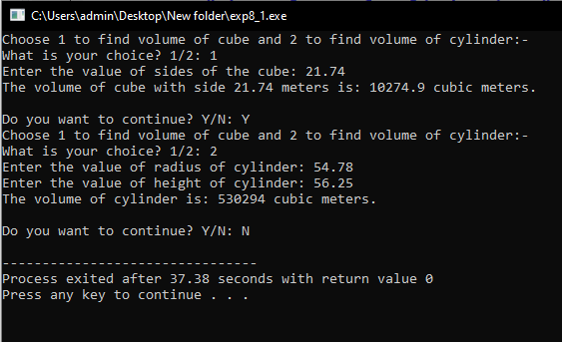

* ***Code:***

#include <iostream>

using namespace std;

double area(float s){

cout<<"The Area of square with side "<<s<<" meters is: ";

return s*s;

}

double area(double r){

const double pi = 3.14159265359;

cout<<"The area of circle is: ";

return pi*r*r;

}

double area(double b, double h){

cout<<"The area of triangle is: ";

return 0.5*b*h;

}

int main(){

char ch;

while(true){

int choice;

cout<<"Choose 1 to find area of square, 2 to find area of circle ";

cout<<"and 3 to find area of triangle :-"<<endl;

cout<<"What is your choice? 1/2/3: ";

cin>>choice;

switch(choice){

case 1:

double side;

cout<<"Enter the measure of side of the square: ";

cin>>side;

cout<<area(side)<<" square meters "<<endl;

break;

case 2:

double radius;

cout<<"Enter the measure of radius of circle: ";

cin>>radius;

cout<<area(radius)<<" square meters"<<endl;

break;

case 3:

double base, height;

cout<<"Enter the measure of base of triangle: ";

cin>>base;

cout<<"Enter the measure of height of height: ";

cin>>height;

cout<<area(base,height)<<" square meters"<<endl;

default:

cout<<"Invalid Choice. Program will end.....!";

break;

}

cout<<"\nDo you want to continue? Y/N: ";

cin>>ch;

if (ch=='N'){

break;

}

}

return 0;

}

* ***Output:***

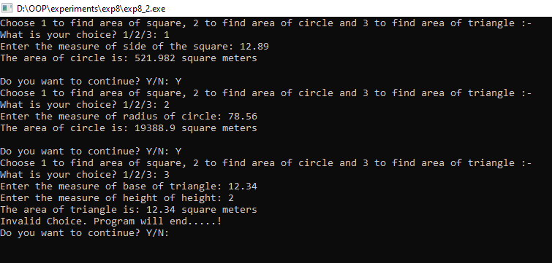

* ***Code:***

#include <iostream>

using namespace std;

int add(int a, int b){

cout<<a<<" + "<<b<<": ";

return a+b;

}

int add(int a, int b, int c){

cout<<a<<" + "<<b<<" + "<<c<<": ";

return a+b+c;

}

int main(){

char ch;

while(true){

int choice;

int num1, num2, num3;

cout<<"Choose 1 to add two numbers and 2 to add three numbers:-"<<endl;

cout<<"What is your choice? 1/2: ";

cin>>choice;

switch(choice){

case 1:

cout<<"Enter the value of num1: ";

cin>>num1;

cout<<"Enter the value of num2: ";

cin>>num2;

cout<<add(num1, num2)<<endl;

break;

case 2:

cout<<"Enter the value of num1: ";

cin>>num1;

cout<<"Enter the value of num2: ";

cin>>num2;

cout<<"Enter the value of num3: ";

cin>>num3;

cout<<add(num1, num2, num3)<<endl;

break;

default:

cout<<"Invalid Choice. Program will end.....!";

break;

}

cout<<"\nDo you want to continue? Y/N: ";

cin>>ch;

if (ch=='N'){

break;

}

}

return 0;

}

* ***Output:***

